TRAFFIC

LOGICAL MODEL

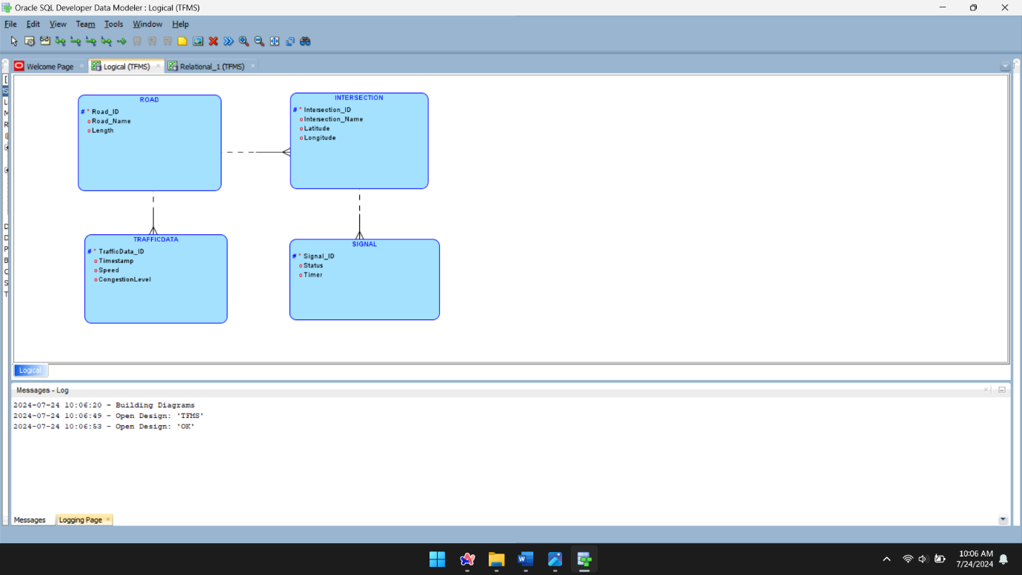

RELATIONAL MODEL

